**Non-*Culex* Sections**:

**Non-*Culex* results**:

1. **Seasonal Prevalence of each Genus:**

From an aggregate of the three collection seasons and all used traps, *Culex*, *Aedes*, and *Anopheles* were the most abundant genera of mosquitoes that we collected (n = 4256, 1638, and 566, respectively). Other genera, such as *Psorophora*, *Uranotaenia*, *Culiseta*, and *Coquillettidia* were less abundant (n = 13, 12, 2, and 1, respectively; Table S2). Adult, female mosquitoes from the genera *Culex* and *Aedes* were collected in gravid and BG sentinel traps into the middle of November in two of the three collection years (November 22, 2019 and November 17, 2022; n = 6 and n = 45, respectively). However, *Anopheles* and *Psorophora* were not collected in gravid and BG sentinel traps after October in any collection season (last fall collection dates were October 21, 2021 and October 25, 2019; n = 1 and n = 1, respectively). *Anopheles* was the only non-Culex genus collected each month from culverts (Table S2). *Anopheles* were the first mosquitoes collected in CDC light in 2022 and gravid, and BG sentinel traps during each collection season (earliest collection March 3, 2022; n = 3). In the 2022 collection season, *Culex* mosquitoes were collected next(March 17, 2022; n = 1), then *Aedes* (April 28, 2022; n = 1), and finally *Psorophora* (May 2, 2020; n = 1; collected once in spring during three years of sampling; Table S2).

1. **Seasonal Prevalence of *Aedes*:**

Relative to *Culex*, far more *Aedes* were collected within BG Sentinel traps (n = approx. 1455), but far fewer were collected within gravid traps (n = 30) or culverts (n = 3; Table S3) in Fall 2021 – Spring 2022. Two groups of *Aedes* were collected during the Fall 2021 - Spring 2022 collection season. The first group consisted of common, multivoltine *Aedes* that were highly abundant during the fall (n = 1,462; species were *Ae. vexans*, *Ae. albopictus*,and *Ae. japonicus*; individual species counts unknown), including blood fed members of *Ae. vexans* and *Ae. japonicus* until mid-November (Table S4). The second group consisted of so-called “springtime” *Aedes* that were collected in May (n = 122; species were *Ae. canadensis* [n = 45], *Ae. stimulans* [n = 53], and *Ae. grossbecki* [n = 24]). During the Fall 2021 – Spring 2022 collection season *Ae. vexans* (n = 44 identified to species) and *Ae. japonicus* (n = 1 identified to species) were found as late in the year as November 17th, and *Ae. vexans* were found as early as April 28th, 2022 (Table S4) from park sites but not culverts. Although *Ae. japonicus* and *Ae. albopictus* were not collected during the spring, *Ae. trivittatus* was found by the 2nd week of May (Table S4).

**Non-*Culex* Tables and Captions:**

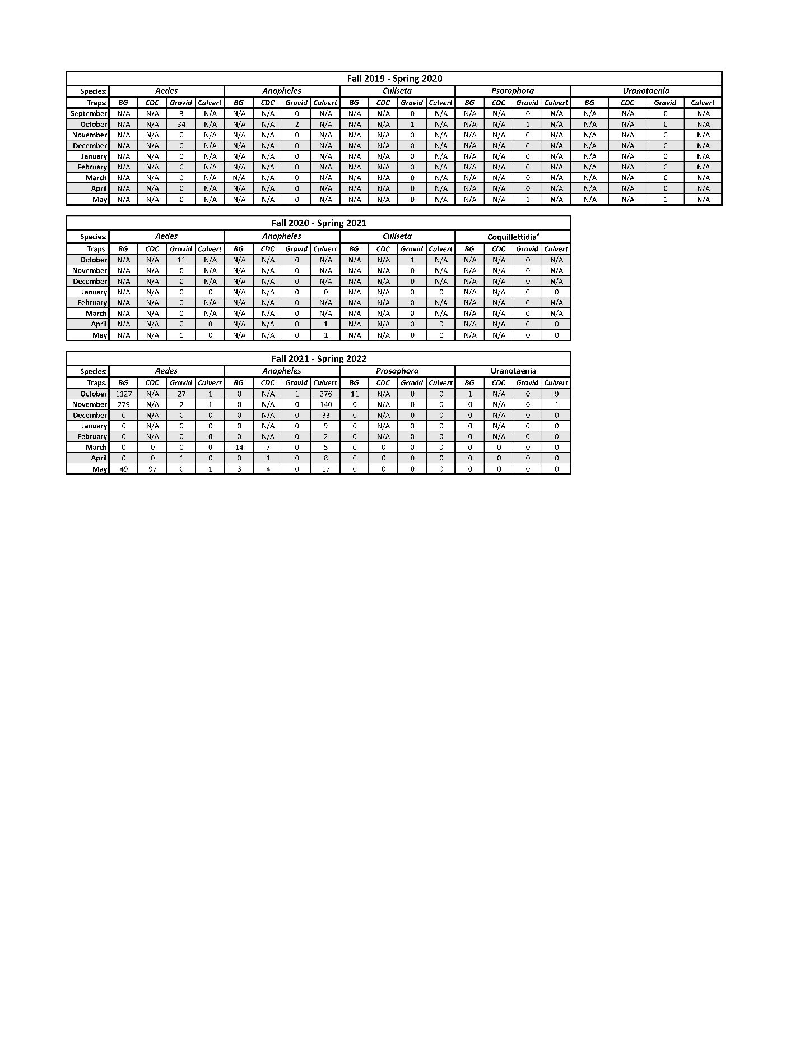

Table S2: The number of non-*Culex* mosquitoes by species that were collected using the four most effective collection techniques across each season. Note that our only *Coquillettidia perturbans* sample was collected from a resting trap on May 16th, 2021.

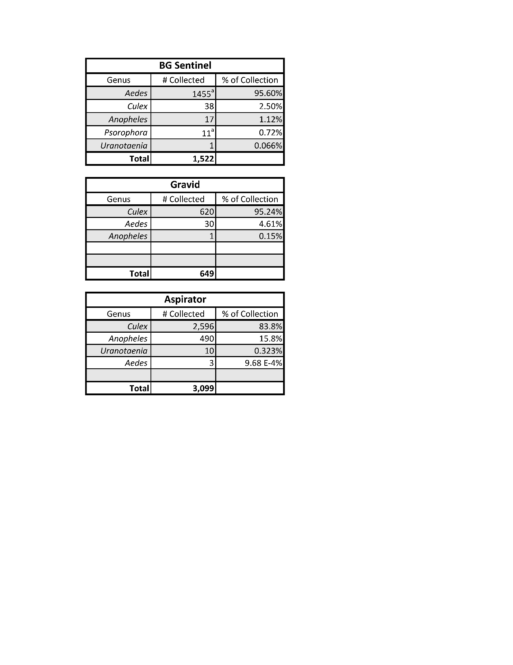

Table S3. Numbers of mosquitoes within each genus collected from different traps during the Fall 2021 to Spring 2022 Collection Season highlighting that different collection techniques are effective in collecting different mosquito genera. Note that not all mosquitoes that were collected on October 14th & 21st, 2021 were identified to genus; during these two collection weeks, *Psorophora* and *Aedes* were grouped together. Due to frequency trends of these genera, we assumed all samples were *Aedes*, although some *Psorophora* could have been collected. Therefore, the numbers of *Psorophora* and *Aedes* collected from BG Sentinel traps may slightly over-estimate the number of *Aedes* and under-estimate the number of *Psorophora*.

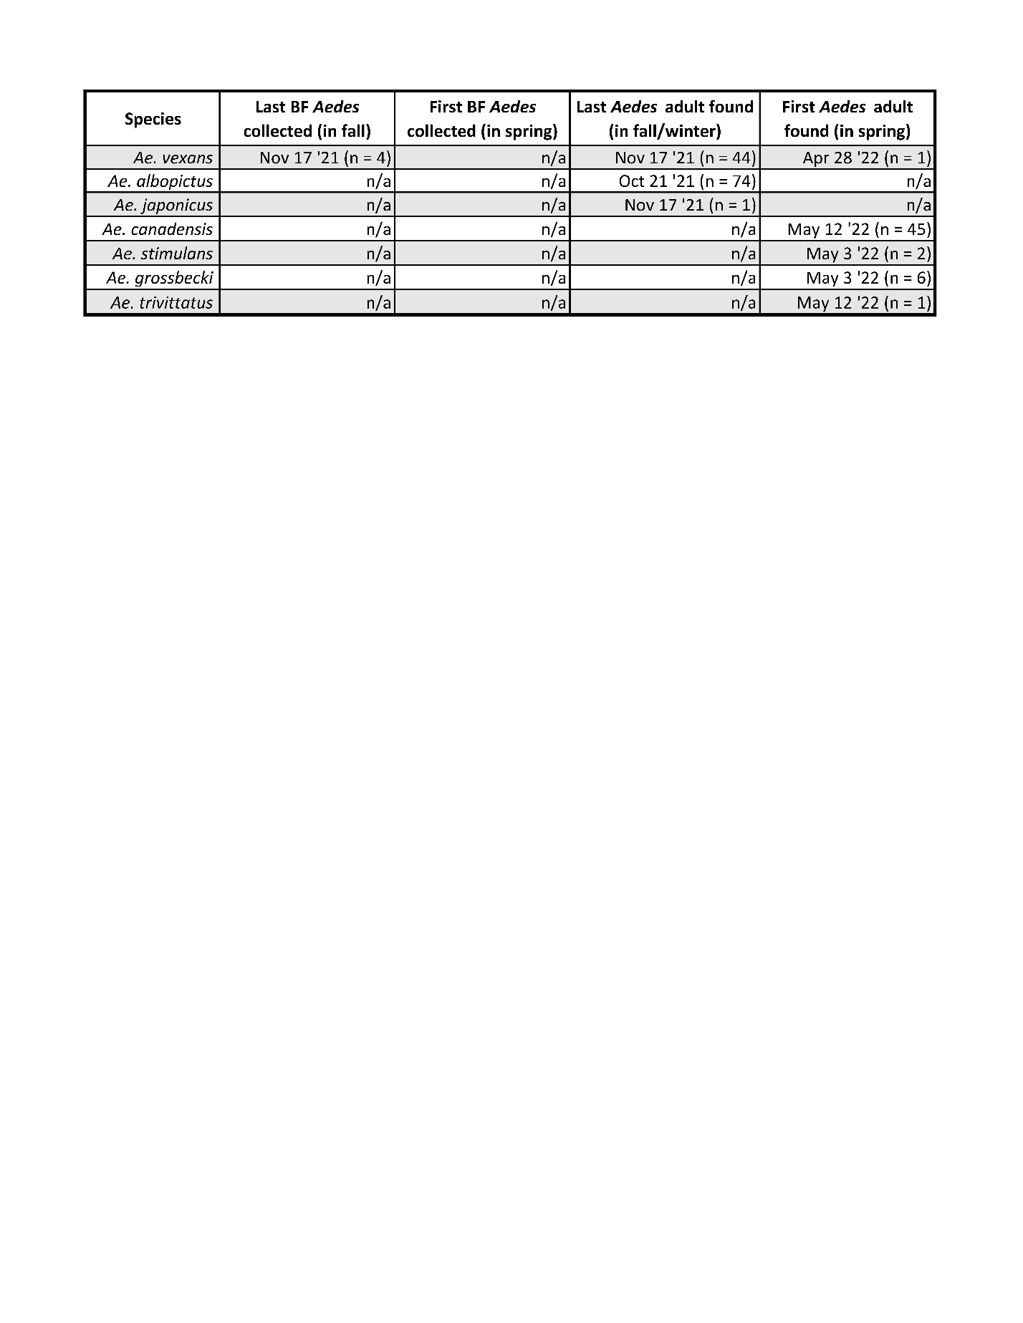

Table S4: Dates when the last and first adult and blood fed (BF) *Aedes* mosquitoes were collected during each collection season.